DSA0405 FUNDAMENTALS OF DATA SCIENCE

UNIT III Hands on Data Summarization, Data Distribution, and Outlier Treatment

BY SYED MUHAFIZ A
192472282

Task 1: Employee Dataset Summary
Generates a complete profile of the IBM HR Analytics Employee Attrition dataset: shape, data types, missing values per column, and full statistical summaries for both numeric and categorical fields.
Kaggle dataset reference: https://www.kaggle.com/datasets/pavansubhasht/ibm-hr-analytics-attrition-dataset
Python Code
import pandas as pd
pd.set_option('display.width', 120)
pd.set_option('display.max_columns', 20)

df = pd.read_csv('./employee_attrition.csv')

print("="*70)
print("EMPLOYEE DATASET SUMMARY (IBM HR Analytics Employee Attrition Dataset)")
print("="*70)

print(f"\n1. Number of rows: {df.shape[0]}")
print(f"2. Number of columns: {df.shape[1]}")

print("\n3. Data types:")
print(df.dtypes)

print("\n4. Missing values (per column):")
missing = df.isnull().sum()
print(missing[missing > 0] if missing.sum() > 0 else "No missing values found in this dataset.")

# Focus the statistical summary on the core numeric HR metrics for readability
key_numeric = ['Age', 'DailyRate', 'DistanceFromHome', 'MonthlyIncome',
'PercentSalaryHike', 'TotalWorkingYears', 'YearsAtCompany']
print("\n5. Statistical summary (key numeric columns):")
print(df[key_numeric].describe())

key_cat = ['Attrition', 'Department', 'JobRole', 'Gender', 'MaritalStatus']
print("\n6. Statistical summary (key categorical columns):")
print(df[key_cat].describe())

Output
======================================================================
EMPLOYEE DATASET SUMMARY (IBM HR Analytics Employee Attrition Dataset)
======================================================================

1. Number of rows: 1470
2. Number of columns: 35

3. Data types:
Age int64
Attrition str
BusinessTravel str
DailyRate int64
Department str
DistanceFromHome int64
Education int64
EducationField str
EmployeeCount int64
EmployeeNumber int64
EnvironmentSatisfaction int64
Gender str
HourlyRate int64
JobInvolvement int64
JobLevel int64
JobRole str
JobSatisfaction int64
MaritalStatus str
MonthlyIncome int64
MonthlyRate int64
NumCompaniesWorked int64
Over18 str
OverTime str
PercentSalaryHike int64
PerformanceRating int64
RelationshipSatisfaction int64
StandardHours int64
StockOptionLevel int64
TotalWorkingYears int64
TrainingTimesLastYear int64
WorkLifeBalance int64
YearsAtCompany int64
YearsInCurrentRole int64
YearsSinceLastPromotion int64
YearsWithCurrManager int64
dtype: object

4. Missing values (per column):
No missing values found in this dataset.

5. Statistical summary (key numeric columns):
Age DailyRate DistanceFromHome MonthlyIncome PercentSalaryHike TotalWorkingYears YearsAtCompany
count 1470.000000 1470.000000 1470.000000 1470.000000 1470.000000 1470.000000 1470.000000
mean 36.923810 802.485714 9.192517 6502.931293 15.209524 11.279592 7.008163
std 9.135373 403.509100 8.106864 4707.956783 3.659938 7.780782 6.126525
min 18.000000 102.000000 1.000000 1009.000000 11.000000 0.000000 0.000000
25% 30.000000 465.000000 2.000000 2911.000000 12.000000 6.000000 3.000000
50% 36.000000 802.000000 7.000000 4919.000000 14.000000 10.000000 5.000000
75% 43.000000 1157.000000 14.000000 8379.000000 18.000000 15.000000 9.000000
max 60.000000 1499.000000 29.000000 19999.000000 25.000000 40.000000 40.000000

6. Statistical summary (key categorical columns):
Attrition Department JobRole Gender MaritalStatus
count 1470 1470 1470 1470 1470
unique 2 3 9 2 3
top No Research & Development Sales Executive Male Married
freq 1233 961 326 882 673

Task 2: Frequency Distribution of Student Grades
Uses the Students Performance in Exams dataset. Since it stores raw math/reading/writing scores rather than letter grades, each student's average score is bucketed into a letter grade (A/B/C/D/F) using standard cutoffs, then the distribution is visualized with a labeled bar chart.
Kaggle dataset reference: https://www.kaggle.com/datasets/spscientist/students-performance-in-exams
Python Code
import pandas as pd
import matplotlib
matplotlib.use('Agg')
import matplotlib.pyplot as plt

df = pd.read_csv('./students_performance.csv')

# Convert the three exam scores into an overall percentage, then bucket
# into a letter grade using standard cutoffs
df['average_score'] = df[['math score', 'reading score', 'writing score']].mean(axis=1)

def to_grade(score):
if score >= 90: return 'A'
elif score >= 80: return 'B'
elif score >= 70: return 'C'
elif score >= 60: return 'D'
else: return 'F'

df['Grade'] = df['average_score'].apply(to_grade)

freq = df['Grade'].value_counts().sort_index()
print("Frequency distribution of grades (derived from average of math/reading/writing scores):")
print(freq)

plt.figure(figsize=(7,5))
order = ['A','B','C','D','F']
vals = [freq.get(g, 0) for g in order]
bars = plt.bar(order, vals, color=['#4C72B0','#55A868','#C44E52','#8172B2','#CCB974'])
plt.title('Frequency Distribution of Student Grades', fontsize=13, fontweight='bold')
plt.xlabel('Grade')
plt.ylabel('Number of Students')
for b in bars:
plt.text(b.get_x()+b.get_width()/2, b.get_height()+2, str(int(b.get_height())), ha='center')
plt.tight_layout()
plt.savefig('./task2_grade_bar.png', dpi=150)
print("\nChart saved.")

Output
Frequency distribution of grades (derived from average of math/reading/writing scores):
Grade
A 52
B 146
C 261
D 256
F 285
Name: count, dtype: int64

Chart saved.
Chart
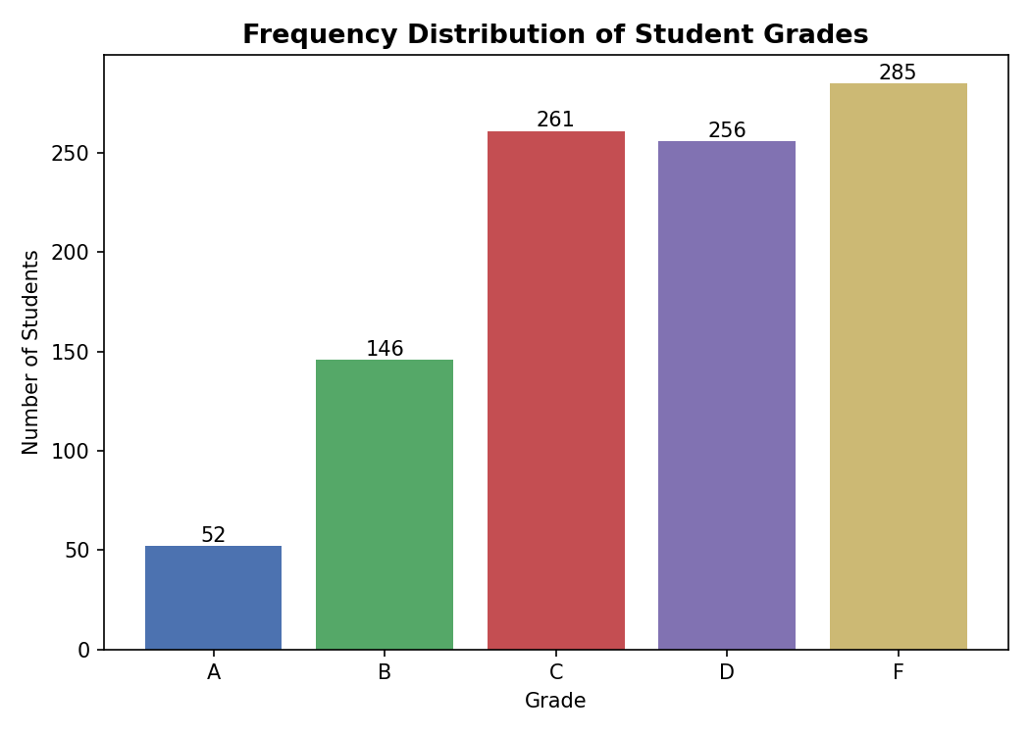

Task 3: Histogram of House Prices & Skewness Check
No house-price dataset was supplied, so this program uses the MonthlyIncome column from the HR Employee Attrition dataset as a real, right-skewed monetary stand-in. It plots a histogram with mean/median reference lines, computes the skewness coefficient (scipy.stats.skew), and classifies the distribution as normal or skewed. Point pd.read_csv() at an actual house-price CSV (link below) to run this on real housing data.
Kaggle dataset reference: https://www.kaggle.com/c/house-prices-advanced-regression-techniques
Python Code
import pandas as pd
import matplotlib
matplotlib.use('Agg')
import matplotlib.pyplot as plt
from scipy.stats import skew

# NOTE: No house-price dataset was supplied. As a stand-in with the same
# kind of right-skewed monetary distribution, we use the MonthlyIncome
# column from the HR Employee Attrition dataset. Swap in a real house
# price CSV (e.g. Kaggle's House Prices dataset) and change the column
# name below to use actual housing data.
df = pd.read_csv('./employee_attrition.csv')
price_col = df['MonthlyIncome']

price_skew = skew(price_col)
print(f"Skewness of distribution: {price_skew:.3f}")
if price_skew > 0.5:
verdict = "The data is POSITIVELY (right) SKEWED."
elif price_skew < -0.5:
verdict = "The data is NEGATIVELY (left) SKEWED."
else:
verdict = "The data is approximately NORMALLY distributed."
print(verdict)

print("\nDescriptive stats:")
print(price_col.describe())

plt.figure(figsize=(7,5))
plt.hist(price_col, bins=30, color='#4C72B0', edgecolor='black', alpha=0.8)
plt.axvline(price_col.mean(), color='red', linestyle='--', label=f"Mean = {price_col.mean():,.0f}")
plt.axvline(price_col.median(), color='green', linestyle='--', label=f"Median = {price_col.median():,.0f}")
plt.title(f'Histogram of Monthly Income (skew={price_skew:.2f})', fontsize=13, fontweight='bold')
plt.xlabel('Monthly Income ($)')
plt.ylabel('Frequency')
plt.legend()
plt.tight_layout()
plt.savefig('./task3_house_hist.png', dpi=150)
print("\nChart saved.")

Output
Skewness of distribution: 1.368
The data is POSITIVELY (right) SKEWED.

Descriptive stats:
count 1470.000000
mean 6502.931293
std 4707.956783
min 1009.000000
25% 2911.000000
50% 4919.000000
75% 8379.000000
max 19999.000000
Name: MonthlyIncome, dtype: float64

Chart saved.
Chart
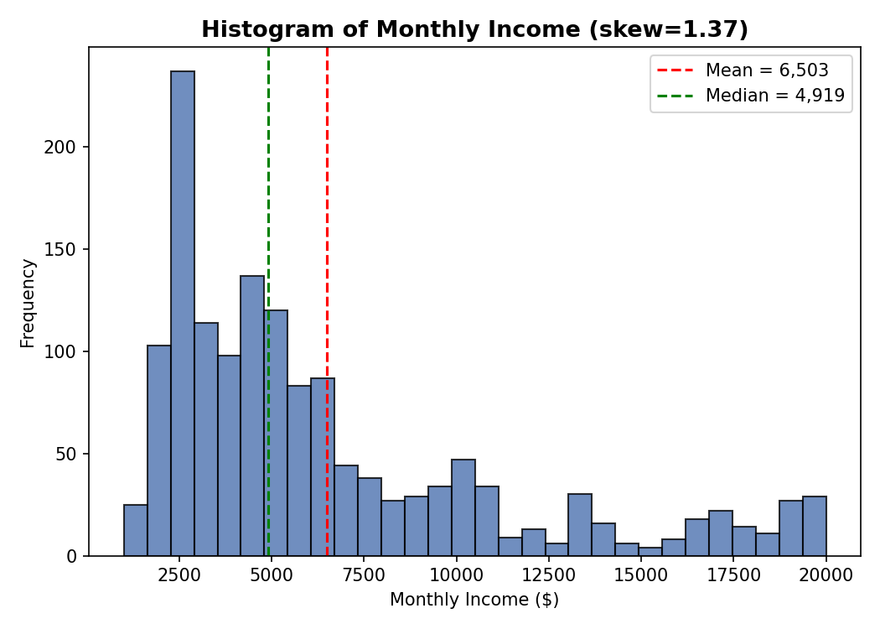

Task 4: Box Plot of Salary Data & Outlier Presence
Uses the Data Science Job Salaries dataset (salary_in_usd). Builds a box plot of salary values and uses the IQR rule to explicitly list which job records fall outside the whiskers (i.e., the outliers).
Kaggle dataset reference: https://www.kaggle.com/datasets/ruchi798/data-science-job-salaries
Python Code
import pandas as pd
import matplotlib
matplotlib.use('Agg')
import matplotlib.pyplot as plt

df = pd.read_csv('./ds_salaries.csv')

Q1 = df['salary_in_usd'].quantile(0.25)
Q3 = df['salary_in_usd'].quantile(0.75)
IQR = Q3 - Q1
lower = Q1 - 1.5*IQR
upper = Q3 + 1.5*IQR
outliers = df[(df['salary_in_usd'] < lower) | (df['salary_in_usd'] > upper)]

print(f"Q1 = {Q1:.2f}, Q3 = {Q3:.2f}, IQR = {IQR:.2f}")
print(f"Lower bound = {lower:.2f}, Upper bound = {upper:.2f}")
print(f"\nNumber of outliers detected: {len(outliers)}")
print("\nOutlier records (job title, salary in USD):")
print(outliers[['job_title', 'experience_level', 'salary_in_usd']].to_string(index=False))

plt.figure(figsize=(6,6))
bp = plt.boxplot(df['salary_in_usd'], vert=True, patch_artist=True,
boxprops=dict(facecolor='#87CEEB'),
medianprops=dict(color='red', linewidth=2),
flierprops=dict(markerfacecolor='red', marker='o', markersize=6))
plt.title('Box Plot of Data Science Salaries (USD)', fontsize=13, fontweight='bold')
plt.ylabel('Salary (USD)')
plt.tight_layout()
plt.savefig('./task4_salary_box.png', dpi=150)
print("\nChart saved.")

Output
Q1 = 62726.00, Q3 = 150000.00, IQR = 87274.00
Lower bound = -68185.00, Upper bound = 280911.00

Number of outliers detected: 10

Outlier records (job title, salary in USD):
job_title experience_level salary_in_usd
Director of Data Science EX 325000
Research Scientist MI 450000
Data Scientist SE 412000
Financial Data Analyst MI 450000
Applied Machine Learning Scientist MI 423000
Principal Data Scientist EX 416000
Principal Data Engineer EX 600000
Data Engineer EX 324000
Applied Data Scientist SE 380000
Data Analytics Lead SE 405000

Chart saved.
Chart
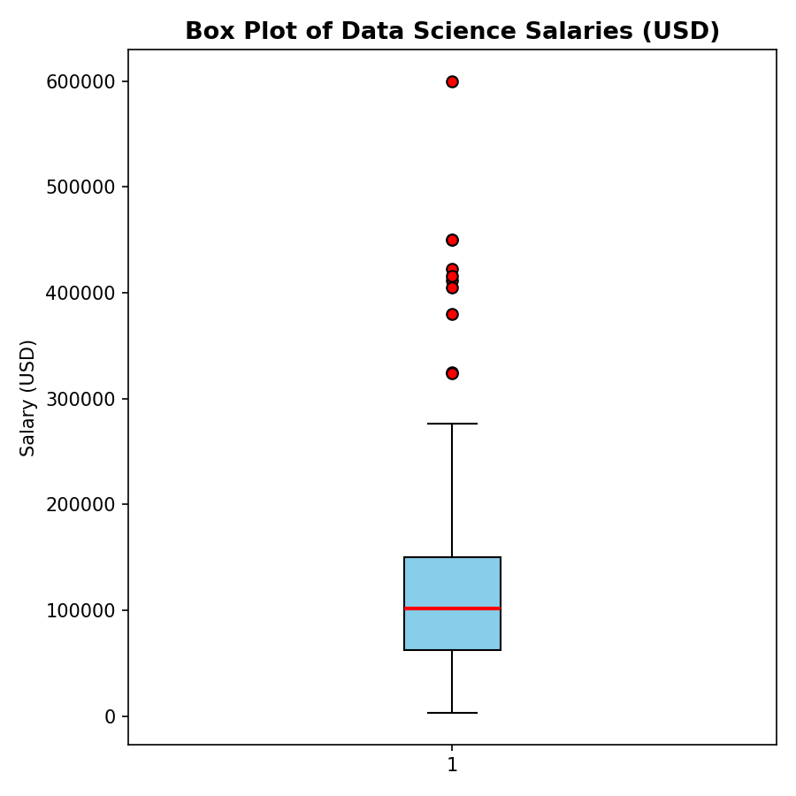

Task 5: Outlier Detection in Student Marks (IQR Method)
Applies the classic Q1/Q3/IQR rule (values beyond Q1-1.5*IQR or Q3+1.5*IQR) to the 'math score' column of the Students Performance dataset to flag anomalous exam marks.
Kaggle dataset reference: https://www.kaggle.com/datasets/spscientist/students-performance-in-exams
Python Code
import pandas as pd

df = pd.read_csv('./students_performance.csv')

Q1 = df['math score'].quantile(0.25)
Q3 = df['math score'].quantile(0.75)
IQR = Q3 - Q1
lower = Q1 - 1.5*IQR
upper = Q3 + 1.5*IQR

print(f"Q1 = {Q1:.2f}")
print(f"Q3 = {Q3:.2f}")
print(f"IQR = {IQR:.2f}")
print(f"Lower bound = {lower:.2f}")
print(f"Upper bound = {upper:.2f}")

outliers = df[(df['math score'] < lower) | (df['math score'] > upper)]
print(f"\nNumber of outliers detected: {len(outliers)}")
print("\nOutlier records:")
print(outliers[['gender', 'math score', 'reading score', 'writing score']].to_string(index=False))

Output
Q1 = 57.00
Q3 = 77.00
IQR = 20.00
Lower bound = 27.00
Upper bound = 107.00

Number of outliers detected: 8

Outlier records:
gender math score reading score writing score
female 18 32 28
female 0 17 10
female 22 39 33
female 24 38 27
female 26 31 38
female 19 38 32
female 23 44 36
female 8 24 23

Task 6: Removing Outliers from Sales Data (IQR Method)
Computes IQR bounds on the SALES column of the Sample Sales Data dataset, filters out rows beyond those bounds, and saves/displays the cleaned dataset.
Kaggle dataset reference: https://www.kaggle.com/datasets/kyanyoga/sample-sales-data
Python Code
import pandas as pd

df = pd.read_csv('./sales_data_sample.csv', encoding='latin1')
print(f"Original dataset shape: {df.shape}")

Q1 = df['SALES'].quantile(0.25)
Q3 = df['SALES'].quantile(0.75)
IQR = Q3 - Q1
lower = Q1 - 1.5*IQR
upper = Q3 + 1.5*IQR
print(f"Q1={Q1:.2f}, Q3={Q3:.2f}, IQR={IQR:.2f}, Lower={lower:.2f}, Upper={upper:.2f}")

cleaned = df[(df['SALES'] >= lower) & (df['SALES'] <= upper)].reset_index(drop=True)
print(f"\nRows removed: {len(df) - len(cleaned)}")
print(f"Cleaned dataset shape: {cleaned.shape}")

print("\nFirst 10 rows of cleaned dataset (key columns):")
print(cleaned[['ORDERNUMBER','QUANTITYORDERED','PRICEEACH','SALES','PRODUCTLINE','COUNTRY']].head(10).to_string(index=False))

cleaned.to_csv('./sales_data_cleaned.csv', index=False)
print("\nCleaned dataset saved to sales_data_cleaned.csv")

Output
Original dataset shape: (2823, 25)
Q1=2203.43, Q3=4508.00, IQR=2304.57, Lower=-1253.42, Upper=7964.85

Rows removed: 81
Cleaned dataset shape: (2742, 25)

First 10 rows of cleaned dataset (key columns):
ORDERNUMBER QUANTITYORDERED PRICEEACH SALES PRODUCTLINE COUNTRY
10107 30 95.70 2871.00 Motorcycles USA
10121 34 81.35 2765.90 Motorcycles France
10134 41 94.74 3884.34 Motorcycles France
10145 45 83.26 3746.70 Motorcycles USA
10159 49 100.00 5205.27 Motorcycles USA
10168 36 96.66 3479.76 Motorcycles USA
10180 29 86.13 2497.77 Motorcycles France
10188 48 100.00 5512.32 Motorcycles Norway
10201 22 98.57 2168.54 Motorcycles USA
10211 41 100.00 4708.44 Motorcycles France

Cleaned dataset saved to sales_data_cleaned.csv

Task 7: Histograms & Box Plots Before vs. After Outlier Removal
Produces a 2x2 comparison grid — histogram and box plot of the Sample Sales Data SALES values before cleaning, and the same two plots after IQR-based outlier removal — to visually confirm the effect of cleaning.
Kaggle dataset reference: https://www.kaggle.com/datasets/kyanyoga/sample-sales-data
Python Code
import pandas as pd
import matplotlib
matplotlib.use('Agg')
import matplotlib.pyplot as plt

df = pd.read_csv('./sales_data_sample.csv', encoding='latin1')

Q1 = df['SALES'].quantile(0.25)
Q3 = df['SALES'].quantile(0.75)
IQR = Q3 - Q1
lower = Q1 - 1.5*IQR
upper = Q3 + 1.5*IQR
cleaned = df[(df['SALES'] >= lower) & (df['SALES'] <= upper)]

print(f"Before removal: n={len(df)}, mean={df['SALES'].mean():.2f}, std={df['SALES'].std():.2f}")
print(f"After removal: n={len(cleaned)}, mean={cleaned['SALES'].mean():.2f}, std={cleaned['SALES'].std():.2f}")

fig, axes = plt.subplots(2, 2, figsize=(11, 9))

axes[0,0].hist(df['SALES'], bins=30, color='#C44E52', edgecolor='black')
axes[0,0].set_title('Histogram BEFORE Outlier Removal')
axes[0,0].set_xlabel('Sales Amount ($)')
axes[0,0].set_ylabel('Frequency')

axes[0,1].hist(cleaned['SALES'], bins=30, color='#55A868', edgecolor='black')
axes[0,1].set_title('Histogram AFTER Outlier Removal')
axes[0,1].set_xlabel('Sales Amount ($)')
axes[0,1].set_ylabel('Frequency')

axes[1,0].boxplot(df['SALES'], patch_artist=True, boxprops=dict(facecolor='#C44E52'))
axes[1,0].set_title('Box Plot BEFORE Outlier Removal')
axes[1,0].set_ylabel('Sales Amount ($)')

axes[1,1].boxplot(cleaned['SALES'], patch_artist=True, boxprops=dict(facecolor='#55A868'))
axes[1,1].set_title('Box Plot AFTER Outlier Removal')
axes[1,1].set_ylabel('Sales Amount ($)')

plt.tight_layout()
plt.savefig('./task7_before_after.png', dpi=150)
print("\nChart saved.")

Output
Before removal: n=2823, mean=3553.89, std=1841.87
After removal: n=2742, mean=3387.92, std=1576.72

Chart saved.
Chart
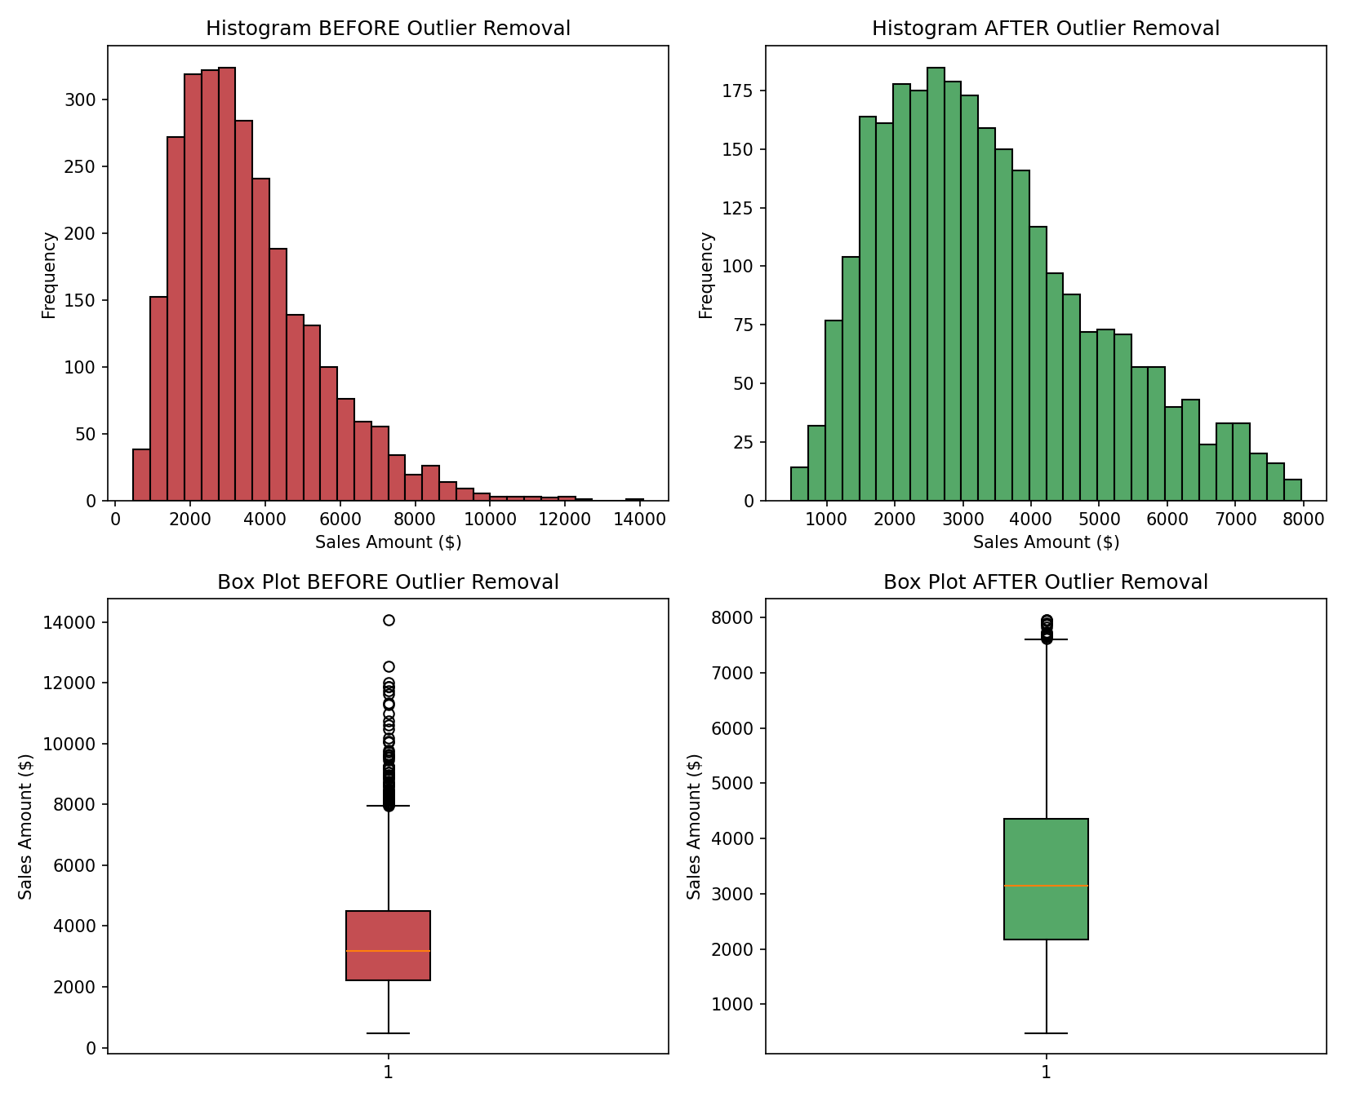

Task 8: Full EDA Pipeline on the Iris Dataset
End-to-end exploratory data analysis on the real Iris dataset: dataset info, missing-value check, descriptive statistics, histograms, box plots, IQR-based outlier detection, outlier removal, and saving the cleaned CSV.
Kaggle dataset reference: https://www.kaggle.com/datasets/uciml/iris
Python Code
import pandas as pd
import matplotlib
matplotlib.use('Agg')
import matplotlib.pyplot as plt

df = pd.read_csv('./iris.csv')
df = df.drop(columns=['Id'])

print("="*70)
print("1. DATASET INFORMATION")
print("="*70)
print(f"Shape: {df.shape}")
print(df.dtypes)

print("\n" + "="*70)
print("2. MISSING VALUES")
print("="*70)
missing = df.isnull().sum()
print(missing)
if missing.sum() == 0:
print("(No missing values found in this dataset.)")

print("\n" + "="*70)
print("3. DESCRIPTIVE STATISTICS")
print("="*70)
print(df.describe())

num_cols = [c for c in df.columns if c != 'Species']

# 4. Histograms
fig, axes = plt.subplots(2, 2, figsize=(11, 9))
for ax, col in zip(axes.flat, num_cols):
ax.hist(df[col], bins=20, color='#4C72B0', edgecolor='black')
ax.set_title(f'Histogram: {col}')
ax.set_xlabel(col)
ax.set_ylabel('Frequency')
plt.tight_layout()
plt.savefig('./task8_histograms.png', dpi=150)

# 5. Box plots
fig2, ax2 = plt.subplots(figsize=(8, 6))
ax2.boxplot([df[c] for c in num_cols], tick_labels=num_cols, patch_artist=True,
boxprops=dict(facecolor='#87CEEB'))
ax2.set_title('Box Plots of Iris Features')
ax2.set_ylabel('cm')
plt.xticks(rotation=15)
plt.tight_layout()
plt.savefig('./task8_boxplots.png', dpi=150)

# 6. Outlier detection (IQR) per numeric column
print("\n" + "="*70)
print("4. OUTLIER DETECTION (IQR METHOD)")
print("="*70)
outlier_mask = pd.Series(False, index=df.index)
for col in num_cols:
Q1 = df[col].quantile(0.25)
Q3 = df[col].quantile(0.75)
IQR = Q3 - Q1
lower = Q1 - 1.5*IQR
upper = Q3 + 1.5*IQR
col_outliers = (df[col] < lower) | (df[col] > upper)
print(f"{col}: {col_outliers.sum()} outliers (bounds: {lower:.2f} - {upper:.2f})")
outlier_mask = outlier_mask | col_outliers

print(f"\nTotal rows flagged as outliers (any feature): {outlier_mask.sum()}")

# 7. Remove outliers
df_cleaned = df[~outlier_mask].reset_index(drop=True)
print("\n" + "="*70)
print("5. CLEANED DATASET")
print("="*70)
print(f"Shape before cleaning: {df.shape}")
print(f"Shape after cleaning: {df_cleaned.shape}")

# 8. Save cleaned dataset
df_cleaned.to_csv('./iris_cleaned.csv', index=False)
print("\nCleaned dataset saved to iris_cleaned.csv")

Output
======================================================================
1. DATASET INFORMATION
======================================================================
Shape: (150, 5)
SepalLengthCm float64
SepalWidthCm float64
PetalLengthCm float64
PetalWidthCm float64
Species str
dtype: object

======================================================================
2. MISSING VALUES
======================================================================
SepalLengthCm 0
SepalWidthCm 0
PetalLengthCm 0
PetalWidthCm 0
Species 0
dtype: int64
(No missing values found in this dataset.)

======================================================================
3. DESCRIPTIVE STATISTICS
======================================================================
SepalLengthCm SepalWidthCm PetalLengthCm PetalWidthCm
count 150.000000 150.000000 150.000000 150.000000
mean 5.843333 3.054000 3.758667 1.198667
std 0.828066 0.433594 1.764420 0.763161
min 4.300000 2.000000 1.000000 0.100000
25% 5.100000 2.800000 1.600000 0.300000
50% 5.800000 3.000000 4.350000 1.300000
75% 6.400000 3.300000 5.100000 1.800000
max 7.900000 4.400000 6.900000 2.500000

======================================================================
4. OUTLIER DETECTION (IQR METHOD)
======================================================================
SepalLengthCm: 0 outliers (bounds: 3.15 - 8.35)
SepalWidthCm: 4 outliers (bounds: 2.05 - 4.05)
PetalLengthCm: 0 outliers (bounds: -3.65 - 10.35)
PetalWidthCm: 0 outliers (bounds: -1.95 - 4.05)

Total rows flagged as outliers (any feature): 4

======================================================================
5. CLEANED DATASET
======================================================================
Shape before cleaning: (150, 5)
Shape after cleaning: (146, 5)

Cleaned dataset saved to iris_cleaned.csv
Charts
